Website Design Brief

Bradley Schouten – Y8

My idea for my website is a cooking website with several baking recipes called ‘The Cookie Corner’

Last time, I was a bit frustrated with the lack of freedom on Wix, so I plan to make my website using HTML, and maybe Wix if that gets too difficult

Some recipes I may include are:

* Brownies
* Cookies
* Melting Moments
* Donuts
* Etc

I plan for each of these to have their own page to meet the minimum page amount of 4.

Below is a draft of what one of these pages may look like:

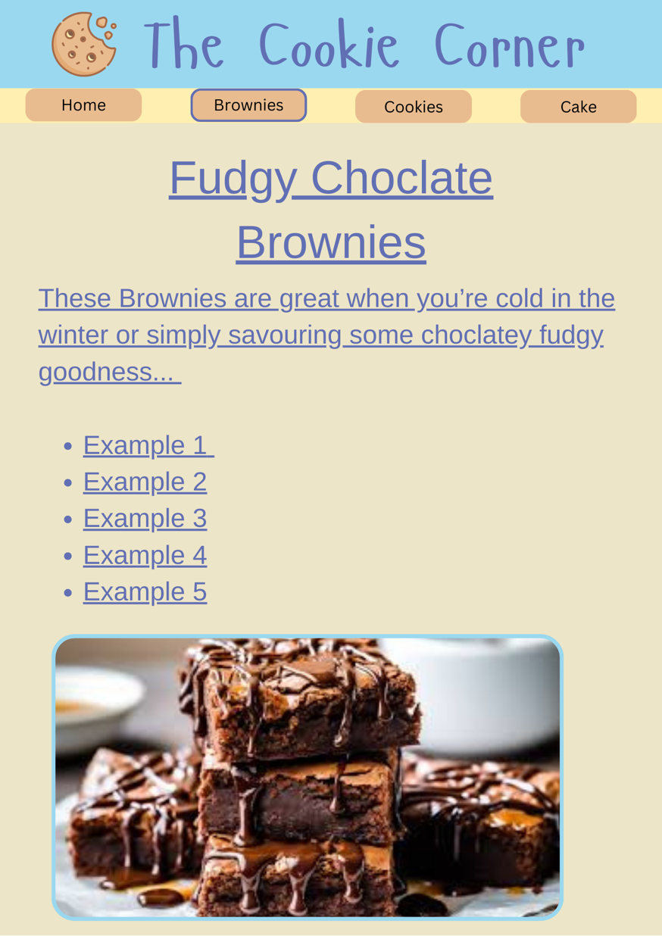

I chose a colour palette of mainly pastels to create a ‘comfy’ sort of mood.